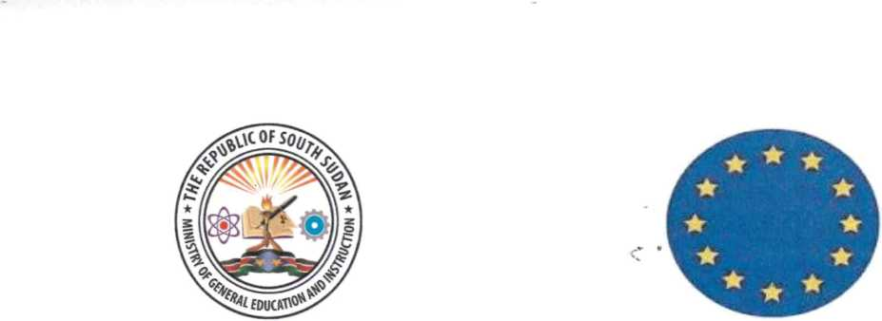

Joint Statement on the European Union (EU) IMPACT Incentives for Primary School

Teachers
The Ministry of General Education and Instruction (MoGE&I) is pleased to announce that the European Union (EU), a long-standing partner of education in South Sudan, has agreed to support the teachers.
Through its ‘IMPACT’ project, the EU has been instrumental to maintain the education system from 2017 to 2020. The exceptional and temporary continuation of the IMPACT programme is triggered by these difficult Covid-19 difficult times. It complements the salaries that the Government owes to the teachers.
Following the reopening of schools in May 2021, both the Ministry and the EU Delegation agreed to pay the exiting IMPACT incentives for 33, 000 Primary School teachers at the end of the first term.
The incentives will be paid in cooperation with UNICEF for teachers in public or state primary schools and alternative learning centres across the country in August 2021. This one-time payment will cover incentives for 3 months, from May to August.
The Ministry is grateful for the dialogue and crucial support that the EU continues to provide to South Sudan and is committed to pursue the self-reliance of an effective and equitable system for general education, through South Sudanese resources.
The Ministry and UNICEF bave commenced the process of validation of teachers in schools. Teachers who will not be validated will not qualify for the incentives. We therefore urge all the teachers in state primary schools to resume their duties immediately. We report that the government is working on the new salary structures for teachers.
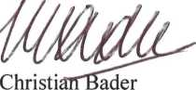
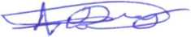

Hon. Awut Deng Acuii. H.E.
Minister Ambassador
Ministry of General Education and Instruction EU Delegation, South Sudan

Wednesday, 16 June 2021

