2022 Nepal-European Union Film Festival KATHMANDU & SURKHET
Complete list of Films

S. N. | Film | Director | Country | Genre | Length | Synopsis | Poster
1 | GODS OF MOLENBEEK | Reetta Huhtanen | Finland, Belgium, Germany | Documentary | 72 min | The district of Molenbeek-Saint-Jean in Brussels has become world-famous as a center of jihadism. | 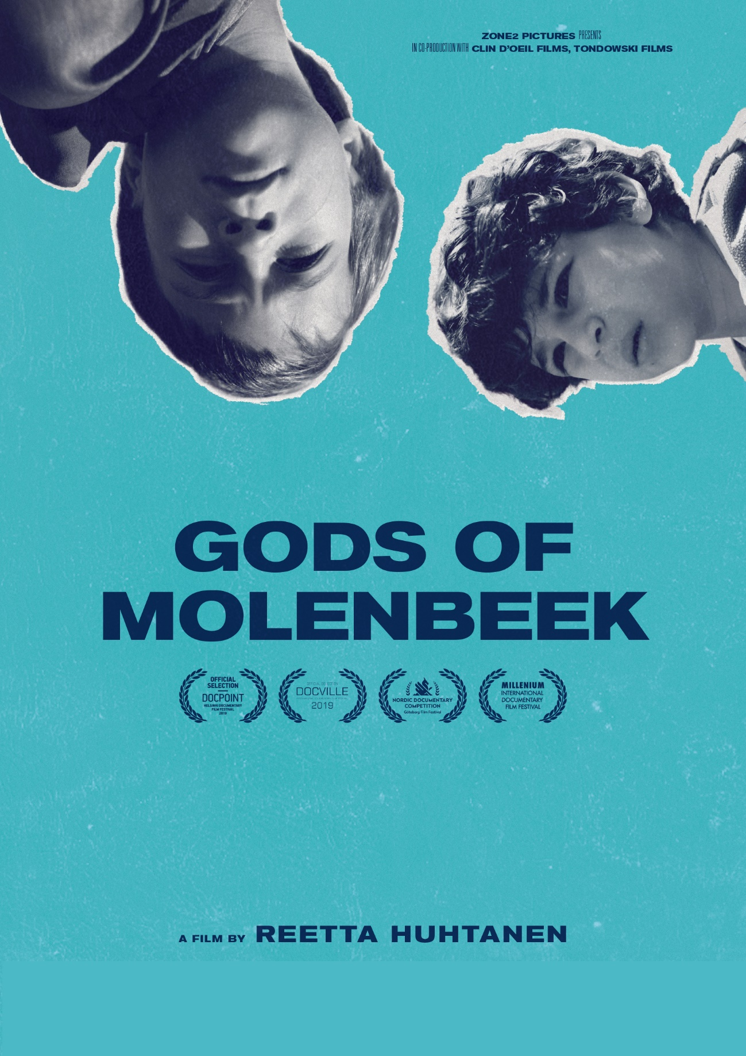
2 | LOLA | Laurent Micheli | Belgium, France | Drama | 90 min | Lola, an 18-year-old transgender girl living in a foster home, learns about the death of her mother and decides to fulfil her mother's last wish with her father.
3 | YET ANOTHER WINTER | Kiran Shrestha | Nepal | Short | 22 Min | A faithful mother follows the rituals of the Shaman and embarks on a journey hoping that her deaf daughter might start to hear and speak. | 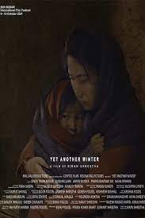
4 | SHADOW COUNTRY | Bohdan Sláma | Czech Republic | Drama | 135 min | How to reconcile with killings committed by your own neighbors? How to face growing evil that nobody stands against? What can human overcome and what is the value of humility and hope? | 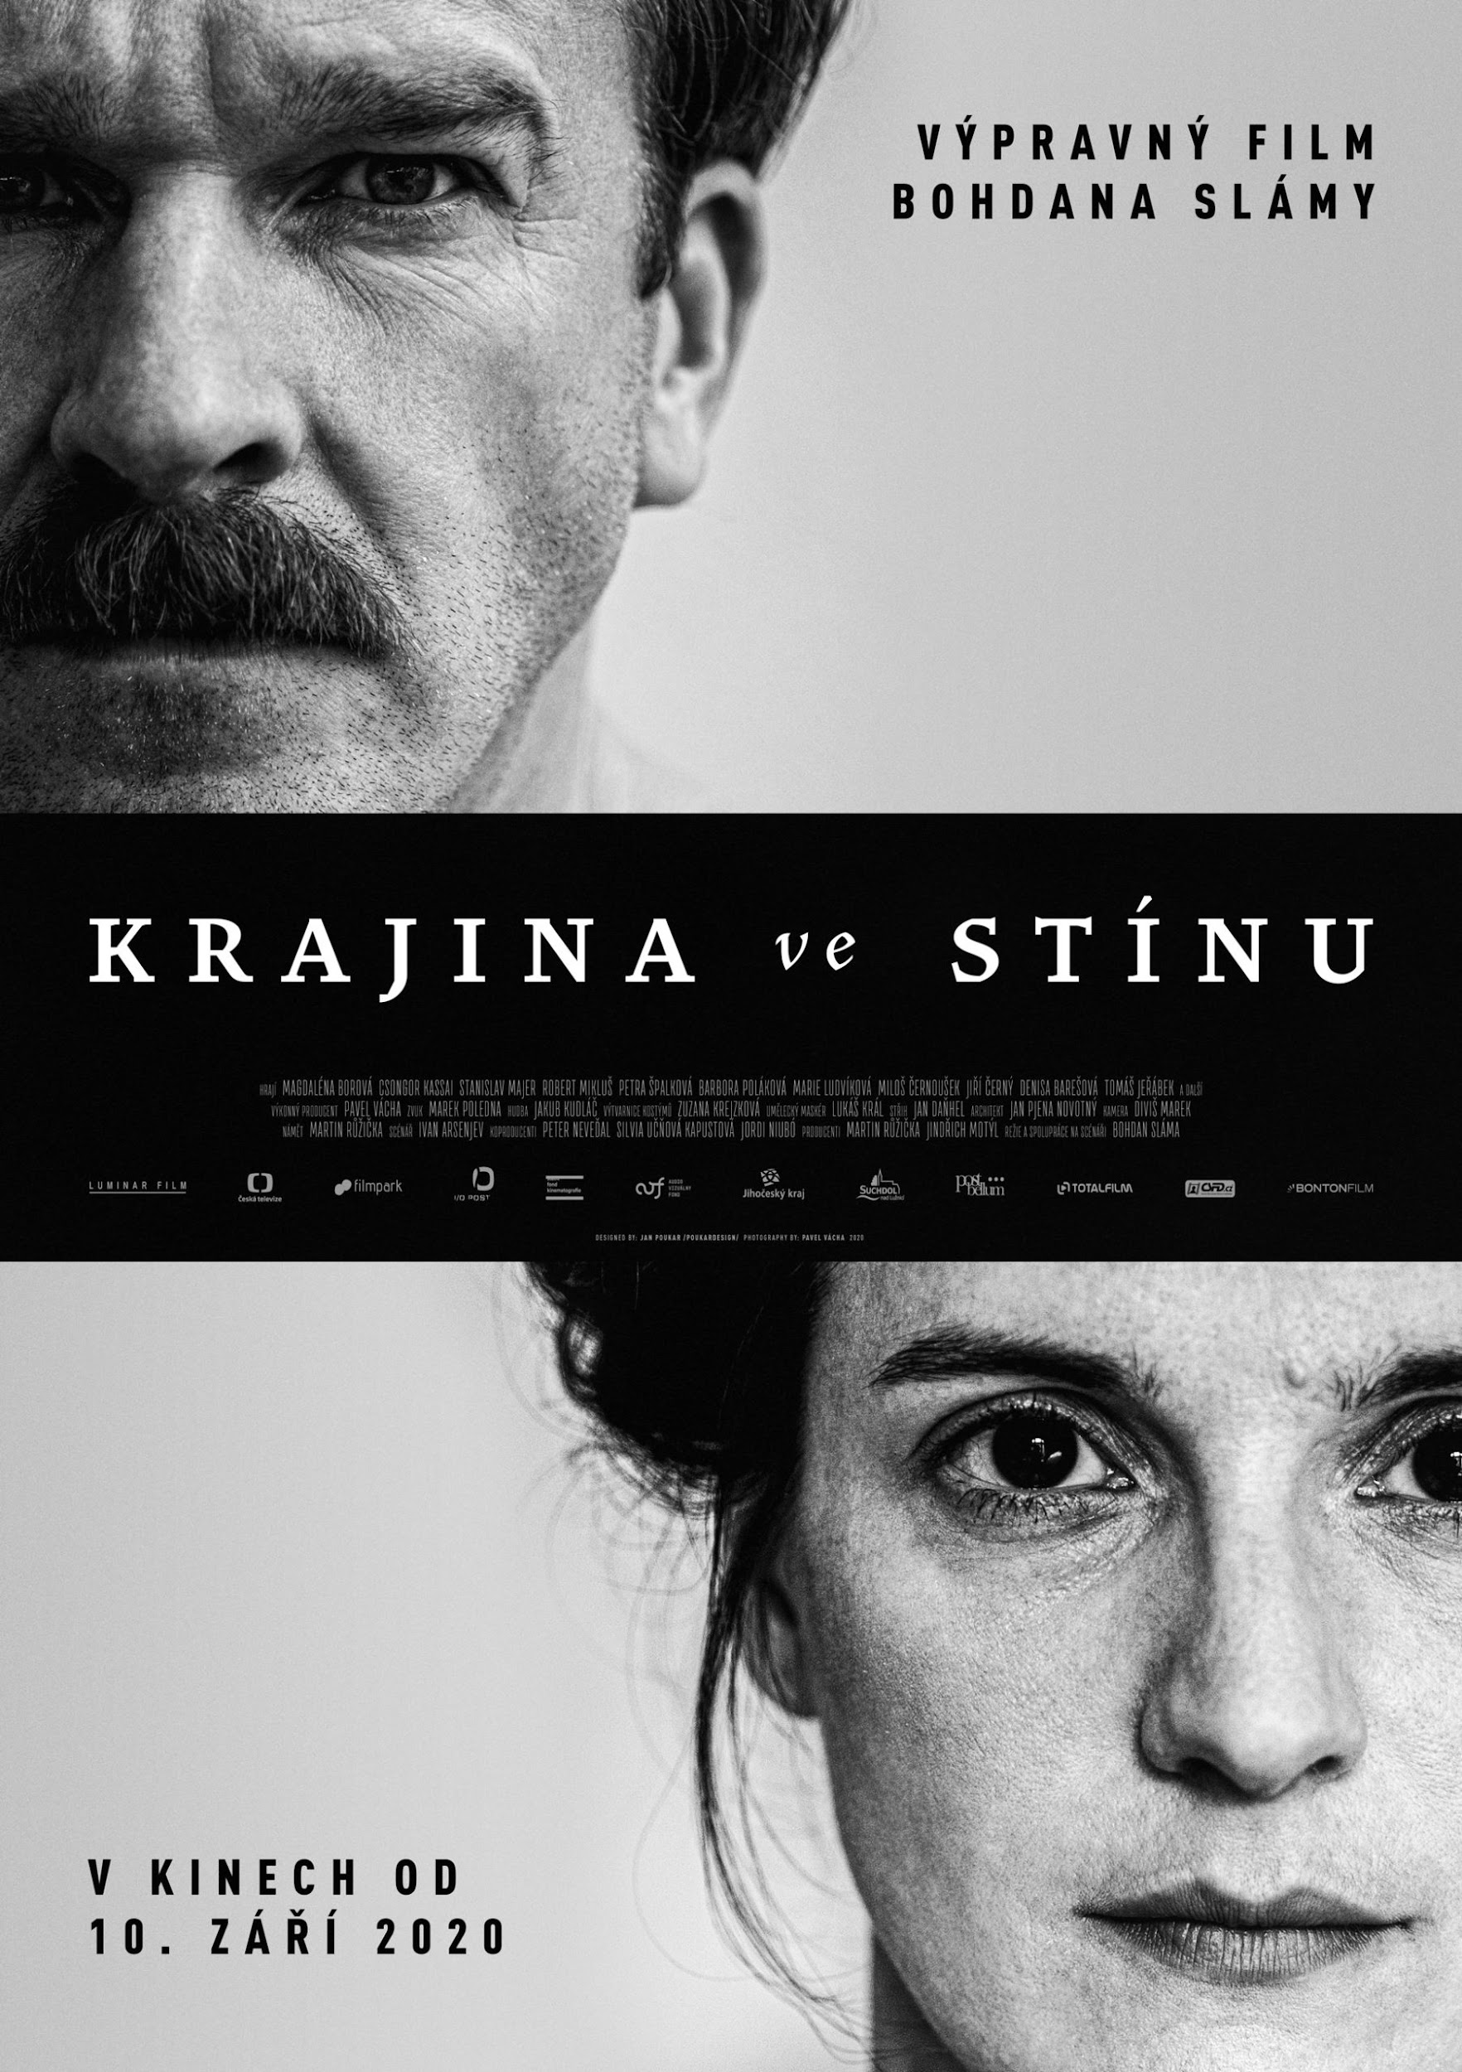
5 | THE BIG HIT | Emmanuel Courcol | France | Comedy | 106 min | An actor past his prime gives drama lessons to prisoners in an attempt to stage "Waiting for Godot."
6 | THE LITTLE COMRADE | Moonika Siimets | Estonia | Drama | 100 min | In the midst of Stalinist tyranny, six-year-old Leelo’s mother is sent to a prison camp. Haunted by her mother’s last words telling her to be a good kid, Leelo vows to be on her best behaviour in the confusing grown-up world in the hope that it will bring her mother back.
7 | PAUSE | Tonia Mishiali | Cyprus, Greece | Drama | 96 min | Trapped in the misery of an oppressive marriage, a middle-aged woman finds refuge in a fantasy world of vindictive violence. Soon, reality and fantasy start to blur. | 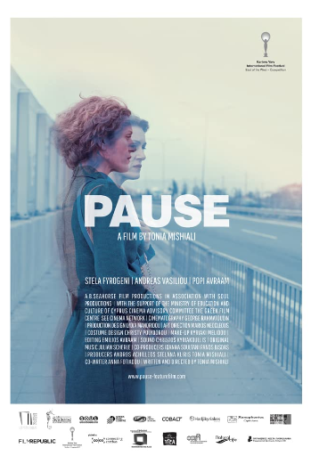
8 | GURKHA GIRL | Bishal Roka Magar | Nepal | Documentary | 35 Min | As news surfaces that Britain is recruiting Nepali girls in its British Gurkha regiments, Dilmaya, a young girl from a rural mountain village, sees it as a life changing opportunity and devotes all her time in preparation. | 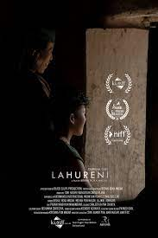
9 | MY THOUGHTS ARE SILENT | Antonio Lukich | Ukraine | Drama | 104 min | Vadim is twenty-two. He's a sound engineer and a downer. He's going to Canada in three months forever. Before the departure he's assigned to record the voice of a very rare bird, which dwells only in the Transcarpath & mountains of Ukraine. | 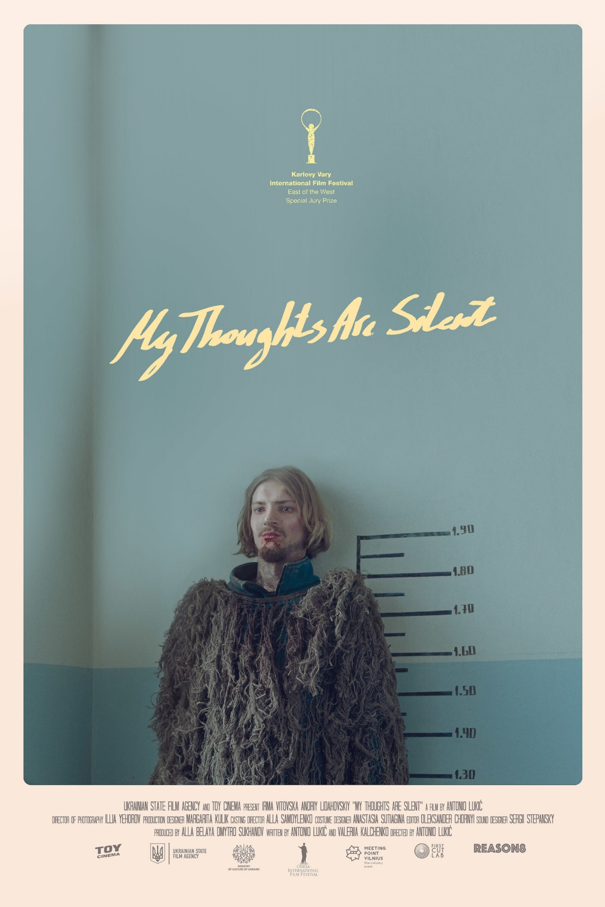
10 | SISTERS APART | Daphne Charizani | Germany, Greece | Drama | 93 min | Rojda, a German soldier and native Kurd, volunteers for a mission to train female Kurdish soldiers in Iraq to fight ISIS. No one must know that she is actually looking for her missing sister. | 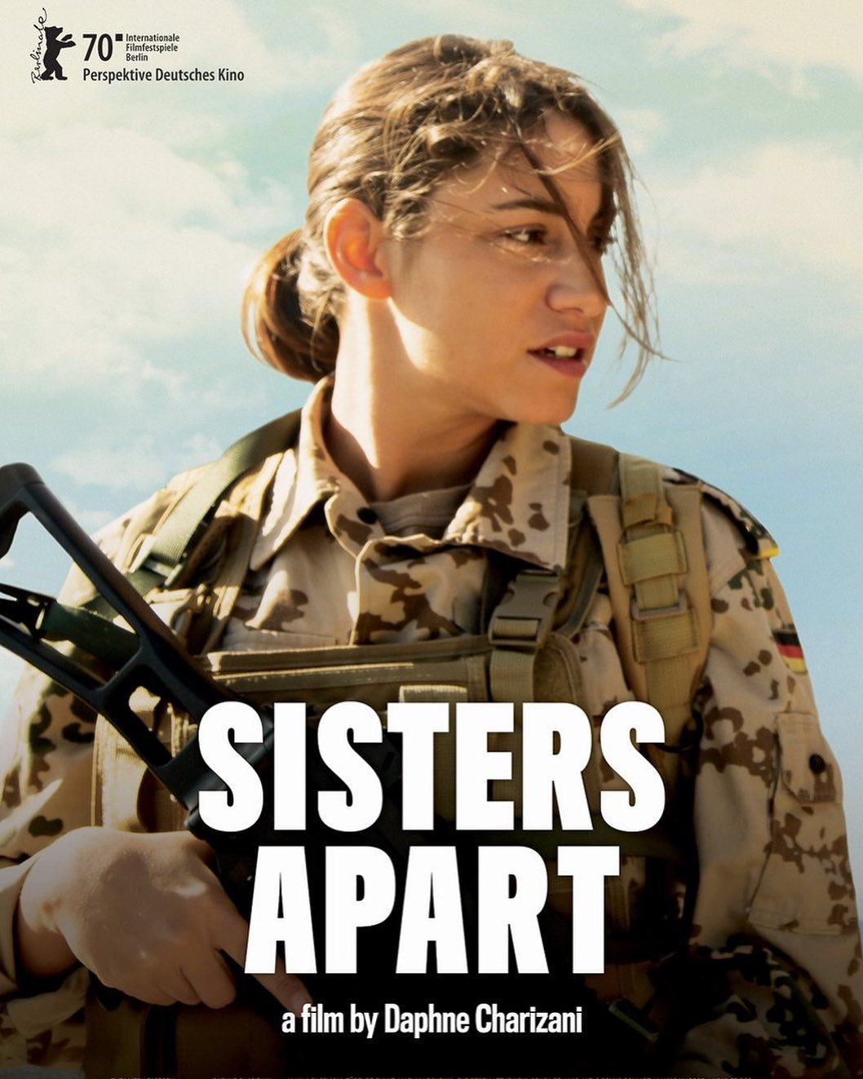
11 | THE FATHER | Kristina GrozevaPetar Valchanov | Bulgaria, Greece | Drama | 90 min | Vasil has just lost his long-time partner in life, his wife Ivanka. When a woman at her funeral proclaims that the dead woman called her cellphone, Vasil seeks out the help of a well-known psychic in order to contact his wife. His son Pavel tries to bring him to his senses, but Vasil stubbornly insists on doing things his own way... | 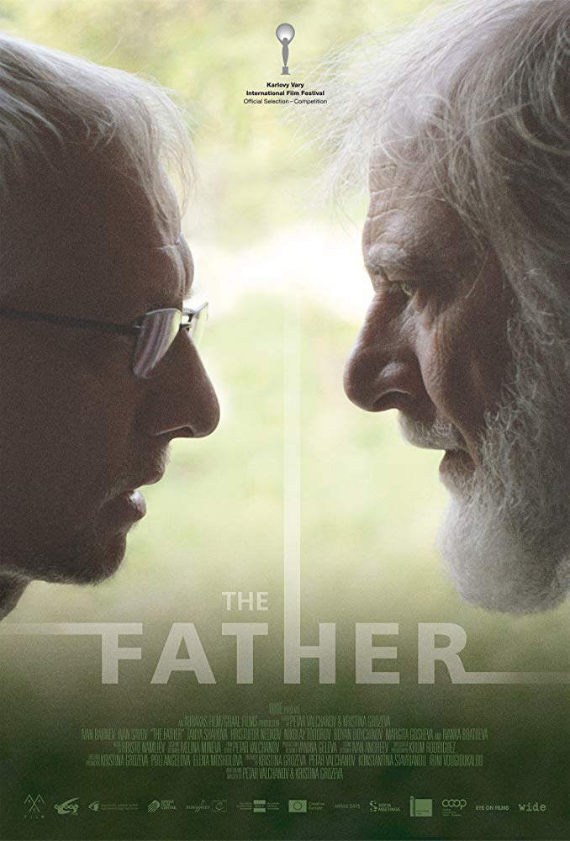
12 | LUZZU | Alex Camilleri | Malta | Drama | 94 min | A man risks everything to provide for his wife and newborn son by entering Malta's black-market fishing industry.
13 | ROMY'S SALON | Mischa Kamp | Netherlands, Germany | Drama | 90 min | Romy has to stay with her grandma Stine after school. It's so boring. Her hairdresser Grandma is strict and in love with her salon. But grandma's memory is not the best, and charming Romy can be at some help with customers and economy. | 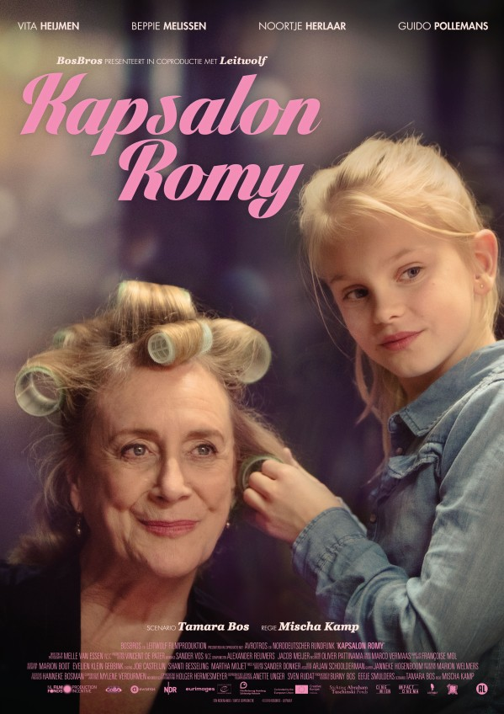
14 | COLD CASE HAMMARSKJÖLD | Mads Brügger | Denmark, Norway, Sweden, Belgium | Documentary | 128 min | Danish director Mads Brügger and Swedish private investigator Göran Björkdahl are trying to solve the mysterious death of Dag Hammarskjöld. As their investigation closes in, they discover a crime far worse than killing the Secretary-General of the United Nations. | 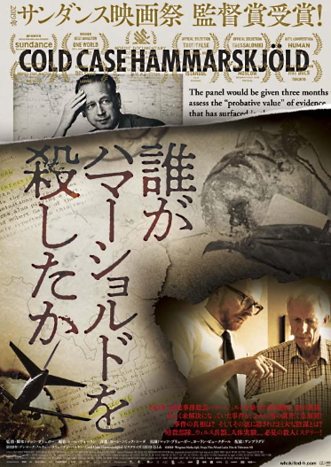
15 | OSKAR & LILY | Arash T. Riahi | Austria | Drama | 102 min | The deportation of two Chechen refugee children from Austria is temporarily suspended after their mother attempts suicide.But what will happen to the family now? | 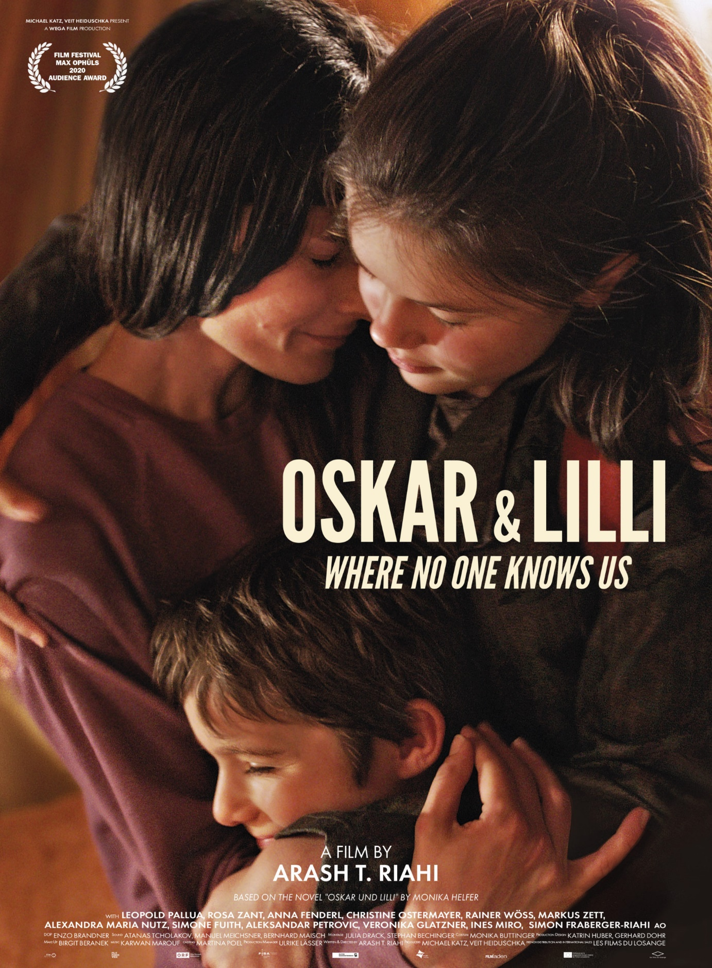
16 | AINA JHYAL KO PUTALI | Sujit Bidari | Nepal | Drama | 96 Min | As the studious Bidhya(13) prepares for her further studies, her juvenile brother Basanta(9) keeps distracting her with his antics. But when he learns that his sister is giving up on her dreams, Basanta struggles to give Bidya the hope and inspiration she desperately needs | 