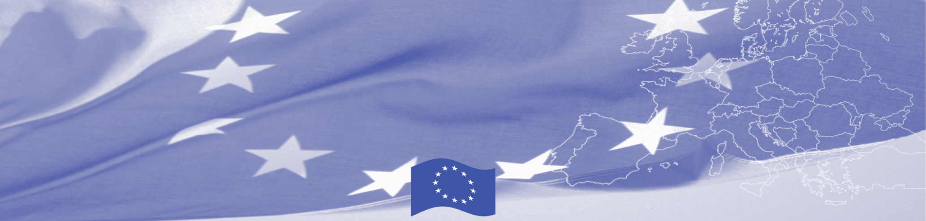
DELEGATION OF THE EUROPEAN UNION
PRESS RELEASE

Kingston, November 6, 2014

GoJ/EU celebrate start of 11th European Development Fund
The European Union today officially handed over documents to the Government of Jamaica to signal the start of the 11th European Development Fund (EDF) Multiannual Indicative Programme. The funding agreement which was earlier signed in September in Apia Samoa covers EU support to Jamaica between 2014 -2020 and has an allocation of €46 million or J$6.45billion (calculated at the current exchange rate). The funding will focus primarily on the areas of Justice and Environment and Climate Change which have received allocations of 50% and 33% respectively. Public Financial Management, support to civil society and support to other areas of development are also covered under the agreement. The 11th EDF programme is not designed by the EU for Jamaica but is driven by the Government of Jamaica and aligned to the National Development Plan “Vision 2030”, prepared with consultations at all levels with government and civil society, aimed at putting resources where they are most needed.

Prime Minister the Hon. Portia Simpson Miller who delivered this morning's key note address noted that the programme comes at an important milestone in the partnership between Jamaica and the EU. The ceremony which was held at the Office of the Prime Minister was hosted by Finance Minister the Hon. Dr. Peter Phillips and attended by resident Ambassadors and representatives of EU Member States in Jamaica.

EU Head of Delegation to Jamaica Ambassador Paola Amadei highlighted that the GoJ-EU partnership has over the years led to significant achievements. "There is indeed much to be celebrated. The 40th year of partnership between Jamaica and the European Union is more than just the sum of the many programs in education, health, security and justice, agricultural and environment and climate change. It is a longstanding relation of partners who share common values and principles, who fight side by side against the same challenges, who can admit frankly when they disagree and work nevertheless to build bridges and advance in their mutual understanding. It is also not just the relationship with Jamaica and the European Union as a bloc but the relationship with one and each of the twenty-eight member States. "

2015 will mark 40 years of development partnership between Jamaica and the EU. Over the years EU support to Jamaica has totalled some €1.2 billion or approximately J$170 billion. EU development cooperation for Jamaica is not limited to current programmes but covers programmes already ongoing in agriculture, education, in health, in economic empowerment as well as funding through programmes designed for the Caribbean region. The EU continues to provide the largest amount of grant funds to Jamaica and to the region: for the period 2014-2020 the combined resources allocated to the Caribbean will amount to 1 billion Euros, a larger amount than ever before.

Contact- Jodi Brown-Lindo
Delegation of the European Union to Jamaica,
Belize, Turks and Caicos Islands, Bahamas and the Cayman Islands
Tel: 1 876 924 6333

