Curriculum Vitae | 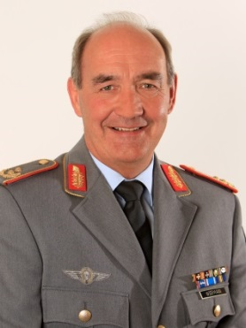

General Lieutenant Hans-W. Wiermann
born
on 20th February 1958
in Soltau, Lower Saxony

Since 21st  August 2015 | German Military Representative NATO to the Military Committee NATO and to the European Union
2013 – 2015  2012 | Commander of Bundeswehr Territorial Tasks Command  Director Security Policy of the Bundeswehr
2007 - 2012 | First Deputy Assistant Chief of Staff for "Politico - Military Affairs and Arms Control", Armed Forces Staff (Fü S III) at the Federal Ministry of Defence, Berlin
2004 - 2007 | Second Deputy Assistant Chief of Staff for "Politico - Military Affairs and Arms Control", Armed Forces Staff (Fü S III) at the Federal Ministry of Defence, Berlin
2002 – 2004 | Military Assistant to the Chief of the General Staff at the Federal Ministry of Defence
2000 – 2002 | Assistant Branch Chief "Force Planning" in the Policy and Advisory Staff of the Federal Ministry of Defence, Berlin
1999 – 2000 | G3 Staff Officer Operations, Plans and Exercises at HQ IV. Corps, Geltow
1997 – 1999 | Commanding Officer Maintenance Battalion 410, Beelitz
1995 – 1997 | Assistant Branch Chief "CFE-Treaty" at the Federal Ministry of Foreign Affairs, Bonn
1993 – 1995 | Assistant Branch Chief "Implementation of Conventional Arms Control Treaties/Agreements and the Chemical Weapons Convention" at the Federal Ministry of Defence, Bonn
1992 – 1993 | Student at the British Army Staff College, Camberley, UK
1990 – 1992 | G 4 staff officer at HQ 1.Armoured Division, Hanover
1988 – 1990 | General Staff Officers' Course at the Bundeswehr Command and General Staff College, Hamburg
1986 – 1988 | Company commander, Maintenance Training Company 5/3, Lüneburg
1983 – 1986 | Maintenance Officer at HQ Maintenance Battalion 3, Rotenburg/W.
1981 – 1983 | Maintenance Officer, Maintenance Company 4./3, Stade
1976 – 1981 | Officer Training, including Studies of Electrical Engineering at the Federal Armed Forces University Hamburg (advanced degree in engineering)
01 July 1976 | Joined the Bundeswehr, served with Maintenance Training Company 15/I, Unna
Promotions
1 July 1979 Second Lieutenant
1 January 1982 Lieutenant
1 January 1985 Captain
1 October 1990 Major
1 October 1993 Lieutenant Colonel
1 April 2002 Colonel
1 October 2007 Brigadier General
27 March 2013 Major General
28 July 2015 Lieutenant General

Medals and Decorations
Silver Cross of Honour of the Bundeswehr
Gold Cross of Honour of the Bundeswehr

Family
Major General Hans-W. Wiermann is married to Susanne Wiermann, née Englert; they have two daughters.

Private interests
Family
Contemporary history
Sports

